# Source Control Guide

Contents

Source Control Guide 1

Prerequisites 1

Getting Source Tree on Your Machine 1

Cloning the Project Demeter Repository 1

Navigating Source Tree 4

Unreal 4

Pushing to Git 5

Verify 7

## Prerequisites

* You will need Unreal Engine 4.25.3
* You will need to sign up for github and create an account
* You will then need to post your email that you used for github to the discord so that your email can be added as a collaborator.

## Getting Source Tree on Your Machine

You can use any source control that works Git that you are comfortable using. That can be Git Desktop, Source Tree, command line/Git Bash, etc. But I am going to cover setting up Source Tree.

Download Source Tree from here: <https://www.sourcetreeapp.com/>

## Cloning the Project Demeter Repository

When Source Tree is finished installing, open it. You will want to find the plus (+) sign. This will bring up the options to Clone, Add, or Create a repository.

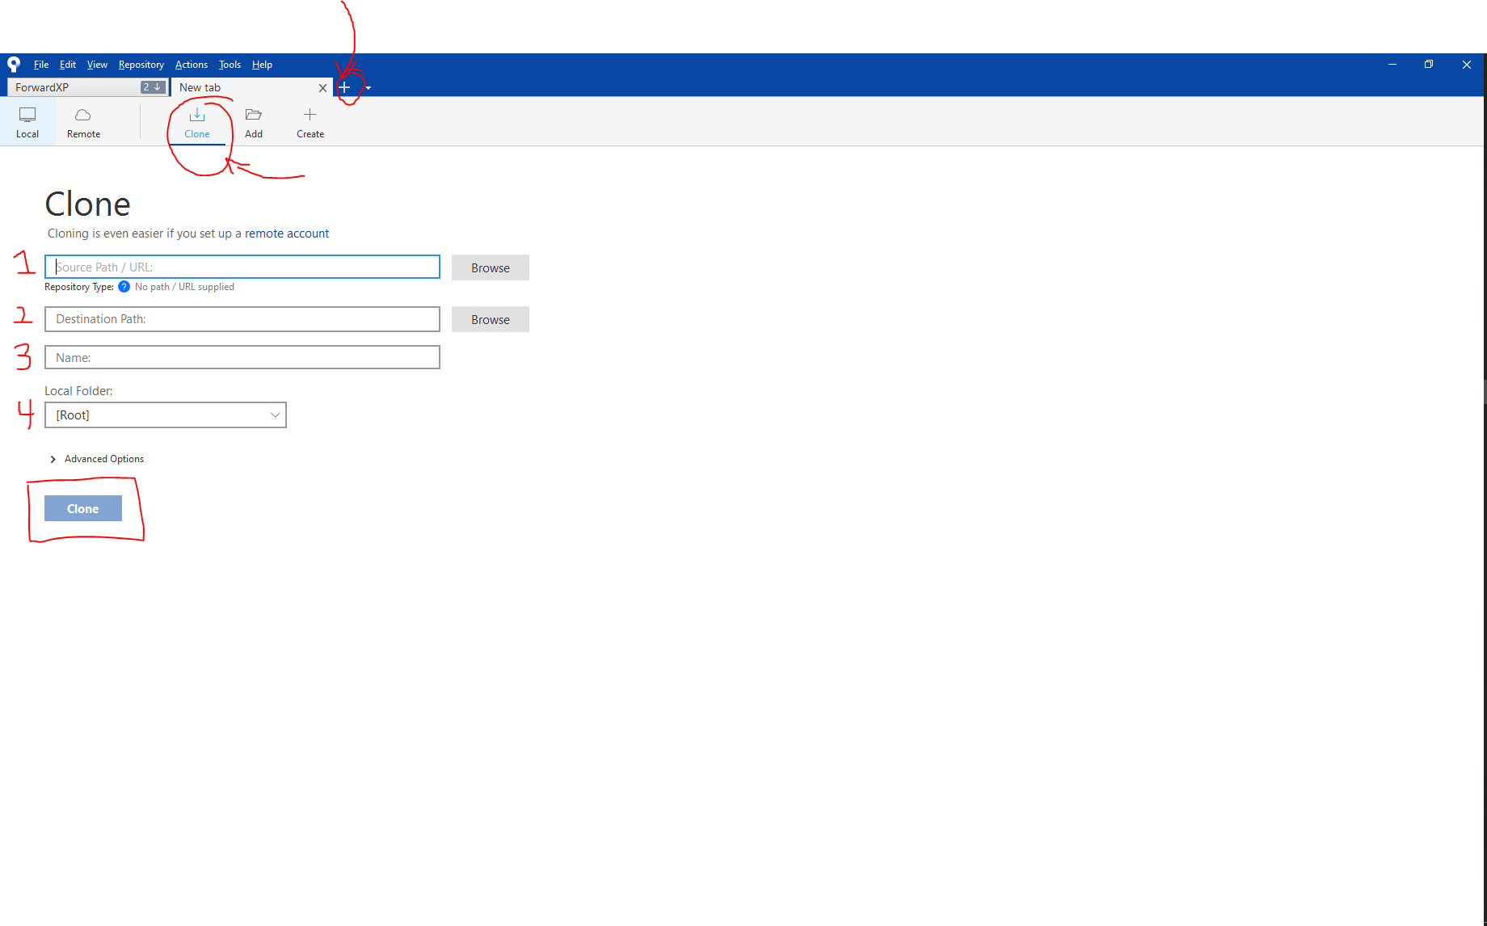

Make sure that you have selected Clone as the option, towards the top. In the screenshot it is circled.

Now, to fill out each section.

1. This section needs the git link for the project. It can be found by going to <https://github.com/projectdemter/ProjectDemeter> and clicking the green button labeled Code.
   1. 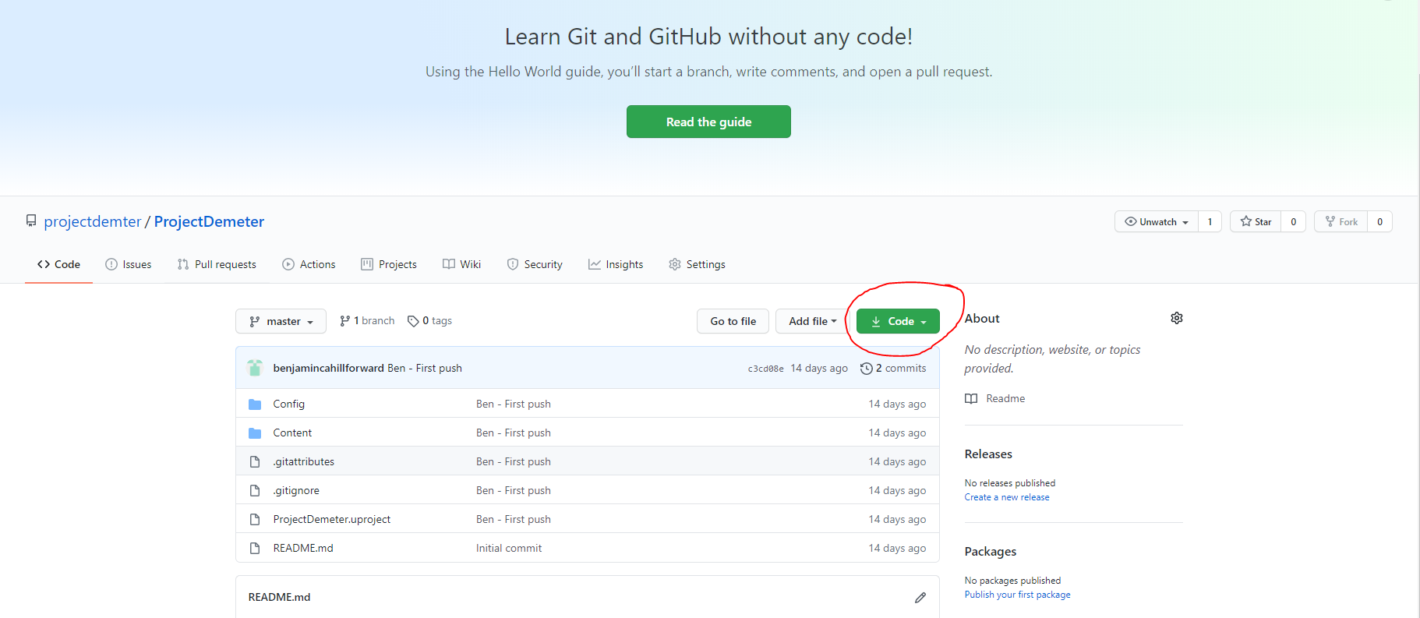
   2. This will give a drop down. Copy the link, it should be <https://github.com/projectdemter/ProjectDemeter.git>
   3. Paste this link into section 1 in Source Tree
2. After pasting the link into section, the other section will attempt to auto fill. Section 2 is stating where you would like this project to be downloaded to. You can use the location it autofilled. This will be somewhere in your C: drive in your Documents folder. I personally like to press Browse and pick a different location.
3. This section is the name you would like to call this project in Source Tree. I recommend this be ProjectDemeter.
4. Leave section 4 as [Root]

When done, it should look something like this.

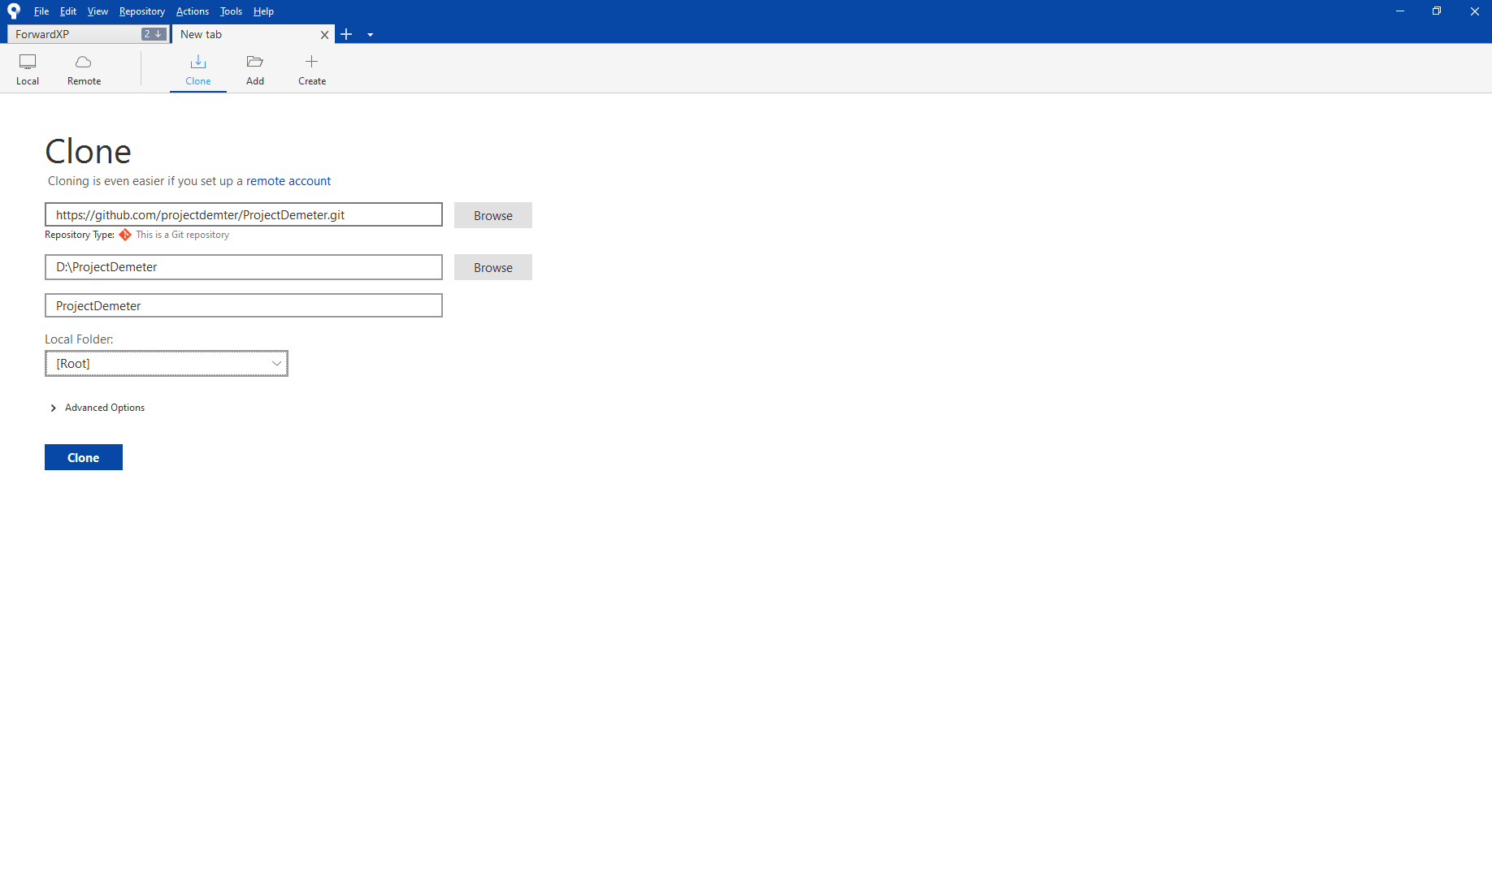Press Clone.

## Navigating Source Tree

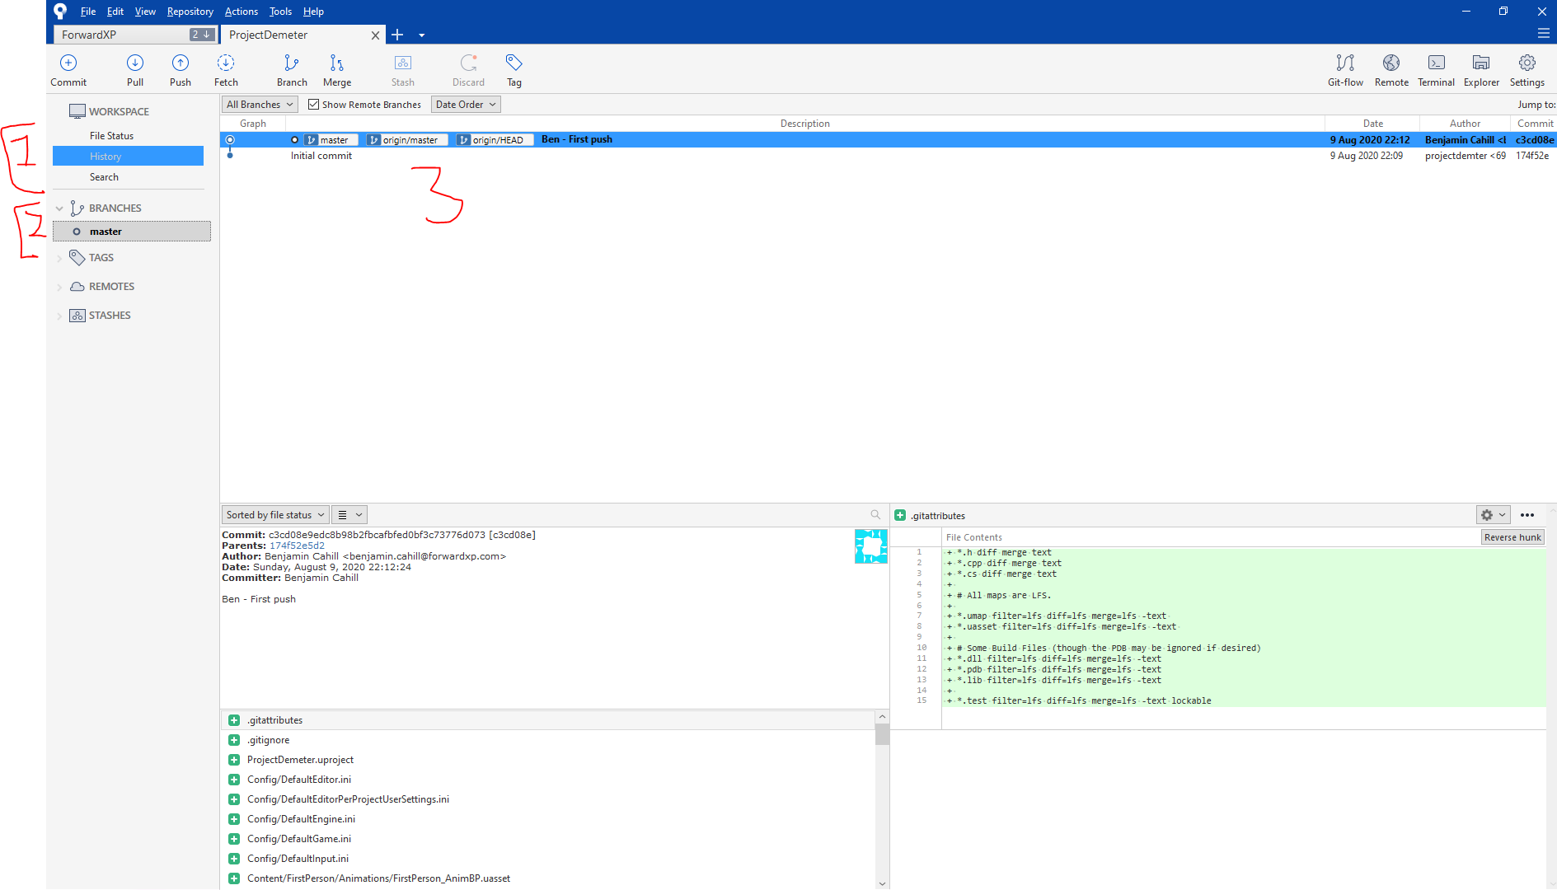

1. On the left, in the area marked by section 1, we see some buttons.
   1. File Status – This will be the section where you can see the files that you are modifying. This will be empty at this time since we are just starting fresh.
   2. History – This will populate the main screen in section 3 with everyone else’s pushes and their push comment.
   3. Search – This will allow you put in search criteria to filter people’s pushes by description or other various criteria
2. Section 2 will show the branches. This should only be populated with master at this time. Branches are something we will not worry about for this project. In a nut shell, this will allow people to multiple versions of the same project in different states.
3. Section 3 will be the main display and will show either the history or file status of your stuff.

## Unreal

Navigate to where you set the git directory and pulled the project into. Double click ProjectDemeter.uproject to open it and Unreal. You should be greeted by this screen.

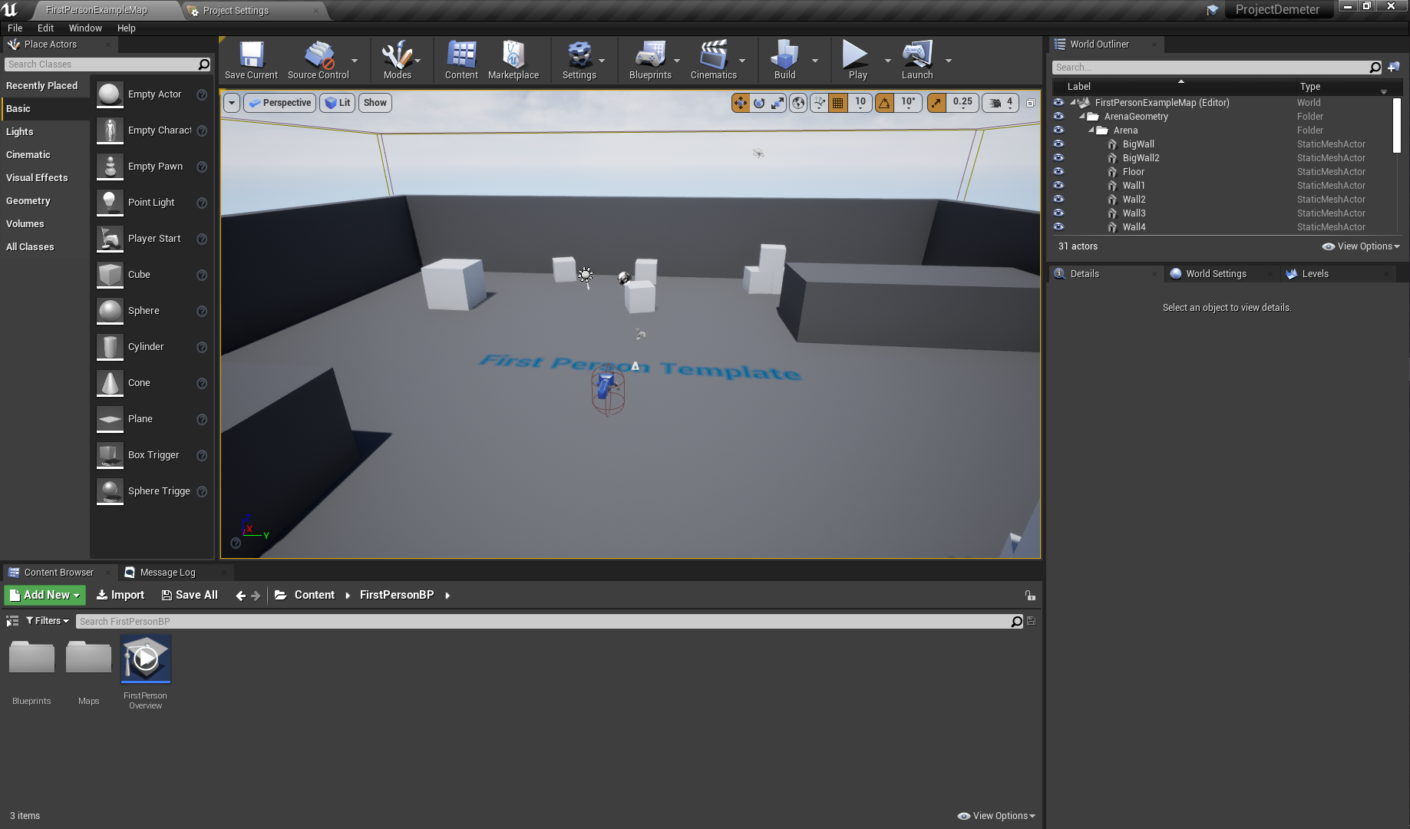

To test everything source control we are going to add a file and push the file.

Add a blueprint, save the project, and close it.

## Pushing to Git

Open Source Tree.

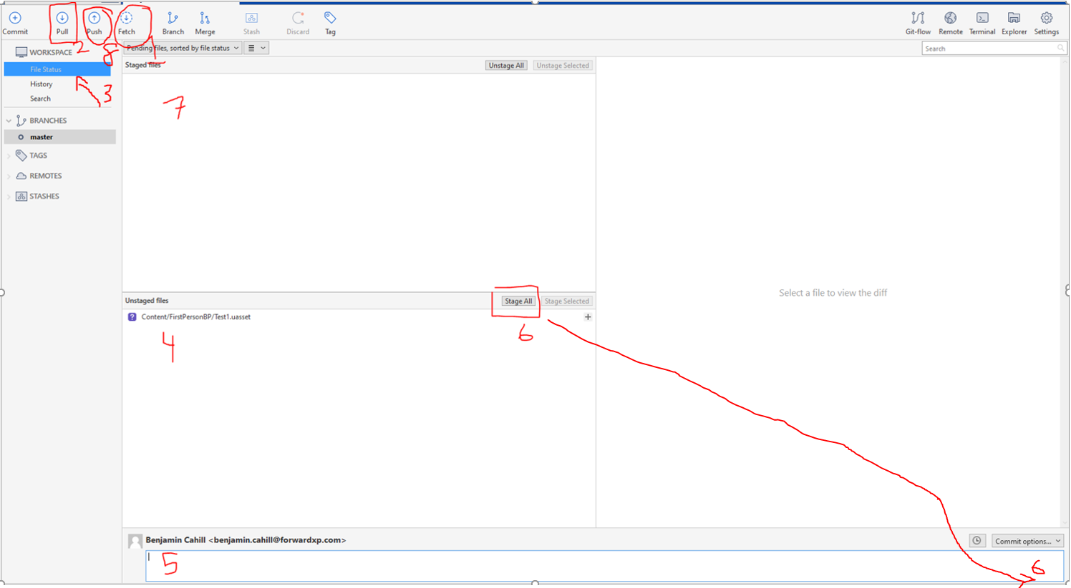

1. This is the Fetch button. It is essentially a refresh of Source Tree. It does a check of the Git project on github to see if anyone else has pushed anything to Git. Get into the habit of pushing this button first as soon as you open Source Tree.
2. If the Fetch did notice that your project is behind on Git, then Pull will have a number displayed. The Fetch DID NOT actually update your project with any pushed files, you must Pull. You need to press Pull now. It is important to Pull before pushing.
3. Navigate to the File Status page. This is the page that shows the status of your project. If there are any new files, any updates/changes to files, any deleted files will be shown.
4. This where you can see the changed files. On the left side of each file there will be an icon, you can hover over it to see what it means.
5. You must type a commit message here before committing and then pushing the changes. This message should briefly describe what you did to the files being committing then pushed. It’s length should be as long as it needs to be to describe what you did, but no longer.
6. Once your message is typed, press Stage All. Or select individual files and Stage Selected. These staged files are the ones that are going to committed then pushed. You can modify files and then not stage them and then those ones will not be committed then pushed. Then in the lower right, you will need to commit the staged files by pressing this button. This will commit the files, but not push them to github. Once they are committed they will disappear from this screen and the Push button will show some numbers of how many commits need to be pushed.
7. Staged files are shown here.
8. Once files are staged, you will see a number next to Push. Push the files and they will get pushed to github.

When you press Push, it will ask for your github login credentials. Enter them here. If your email has not been added as a collaborator, you will get an error at this time saying that you do not have permission. Try again once you receive notification you have been added as a collaborator.

## Verify

Check out the github project page to see if you see your commit message.